Creating Pieced Announcement Pillow In The Hoop
240x360mm (9.44”x14.2”)

This pillow perfect for personalized Birthday Announcement, any other divided messages or as seasonal home décor project!
Pillow size can be 240x360m or bigger if you add extension pieces of fabric.
Pillow diagram:
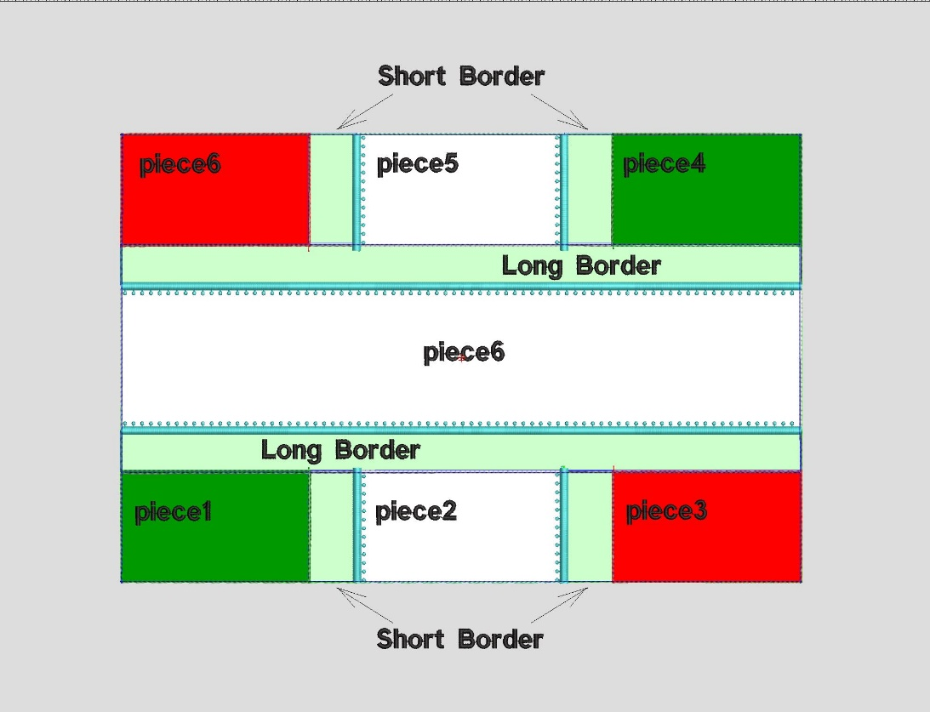

For assembling pillow in the hoop you need;
- Tearaway stabilizer
- Fabric:

- Background fabric (min 11x15”)
- Center piece Fabric – size 4x15”
- Fabric for Pieces 1,3,4,6 – size 3x4.5”
- Fabric for Pieces 2,5 – size 3x4.5”
- Fabric for 4 Short Borders -1.75x 3” each
- Fabric for 2 Long Borders -1.75x 15” each
- Fabric for pillow back
- Extension fabric – optional

  - Thread. Design includes many thread colors which show different stage of creating pillow and machine stops, but you can use any thread color matched with your fabric.

  - Additional design for pillow decoration.

  - Sewing machine for assembling pillow.

Hoop only the stabilizer (or stabilizer and background fabric - optional) your finished design will be on.

Instruction

- Run machine and stitch outline directly on stabilizer (or stabilizer and background fabric).
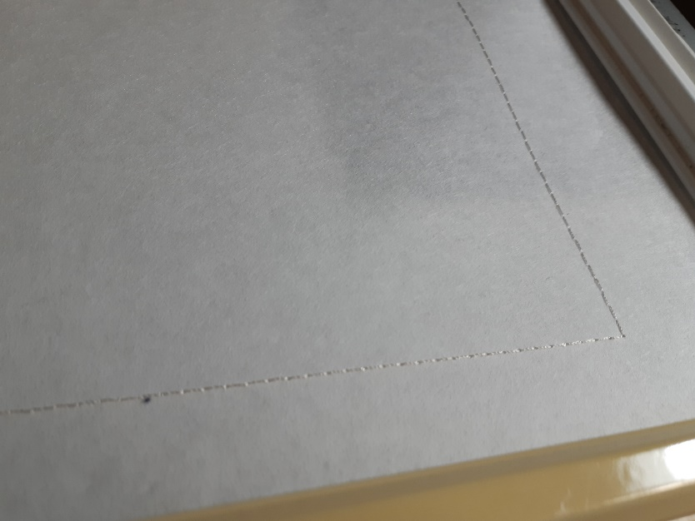

- In this stage you can add background fabric if you are not hoop it in stage 1. Run machine and embroider the next color (it's outline of the design).
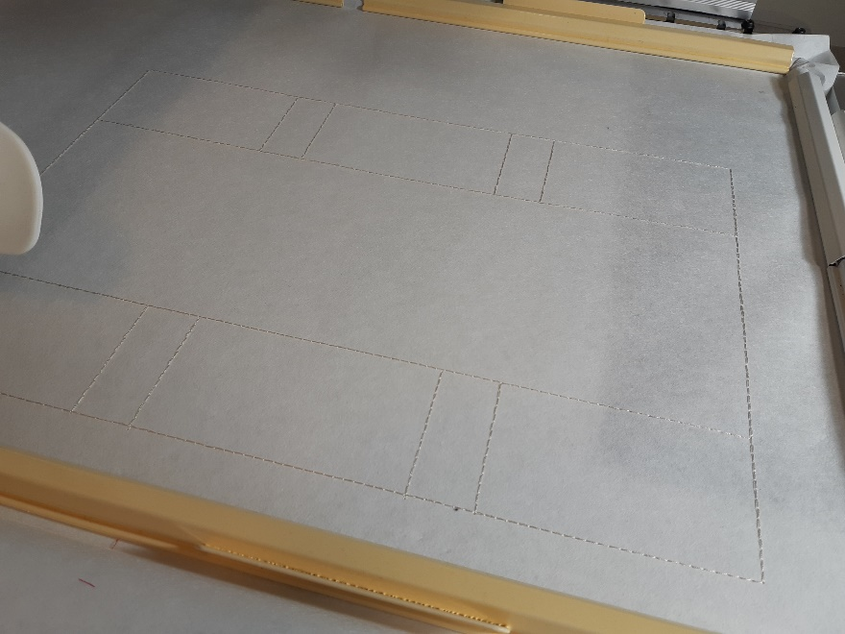

- Secure piece by piece of patch using quilter's tape, temporary glue spays, etc. and tackle them according diagram.
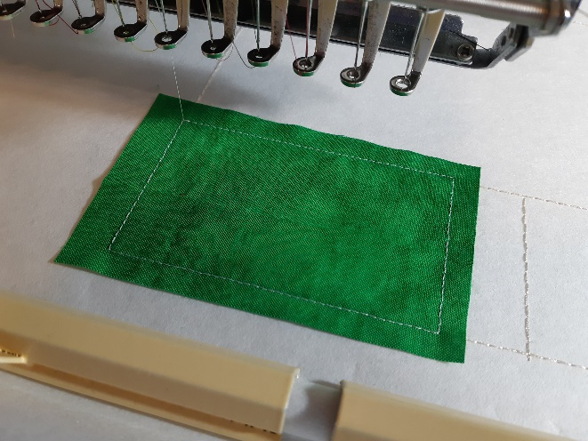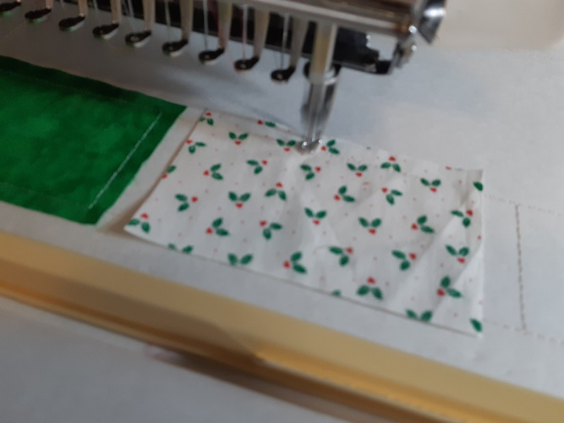

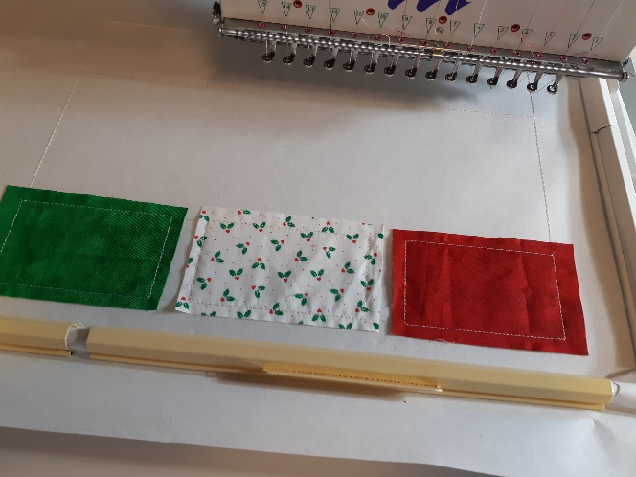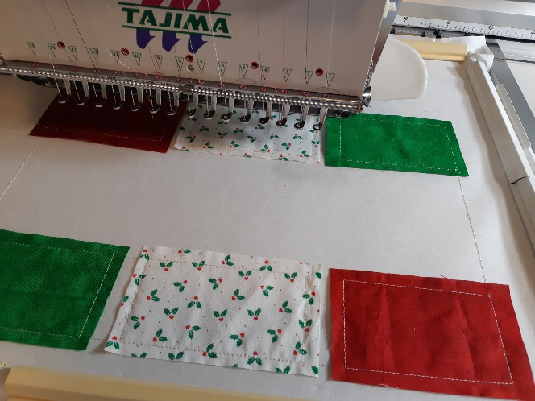

- Apply Short Border
a - layout border upside down fabric
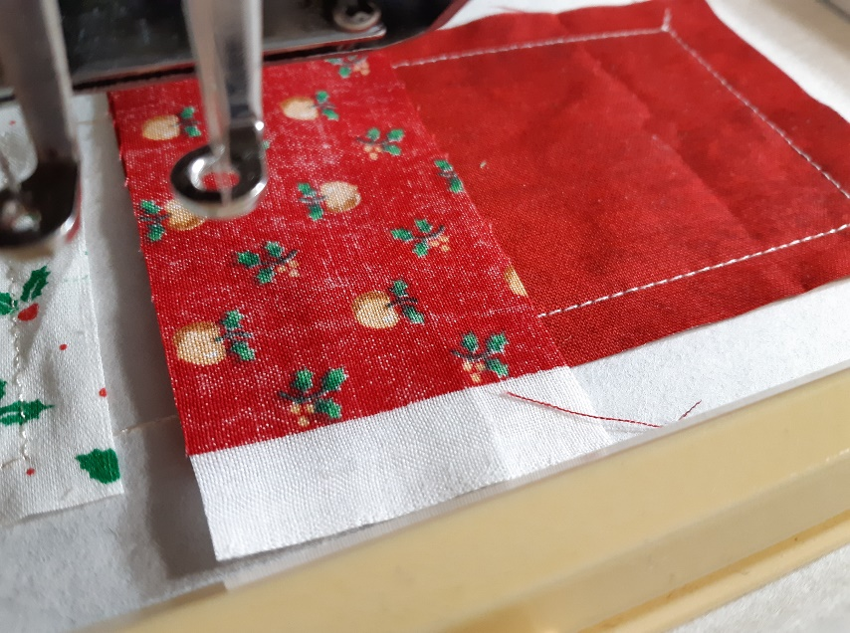
b – stitch seam to connect piece with border
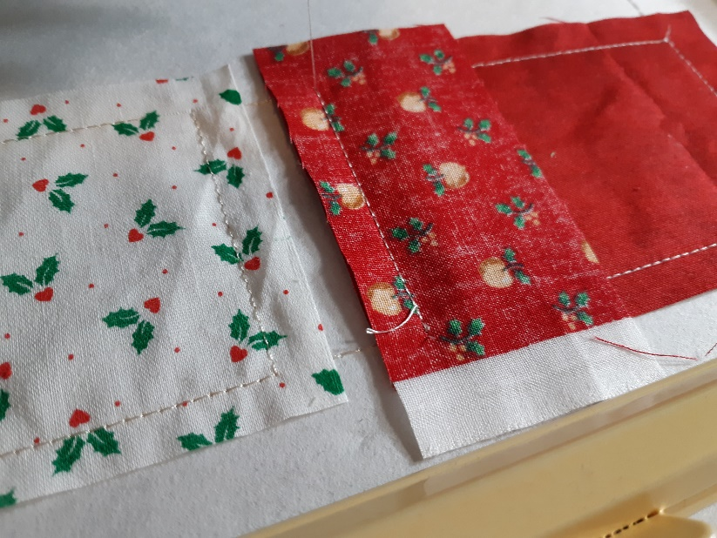
c – bend border
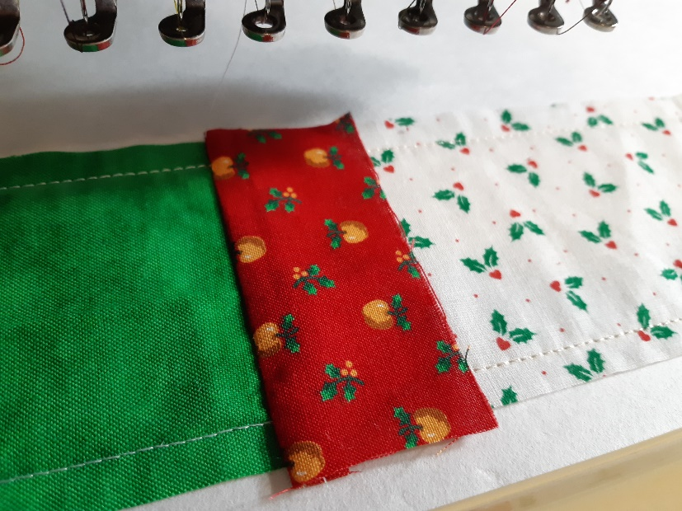
d - Tacking border from second side. Stitch up to zigzag. It will indicate the aria their fabric will cut away. Remove hoop and cut extra fabric over seam. Place the hoop on a flat surface and carefully cut fabric next to zigzag stitches to remove the excess fabric. Use an applique scissors for it. Avoid cutting the zig zag stitches that edge the design. After trimming, your embroidery should look similar to this photo.

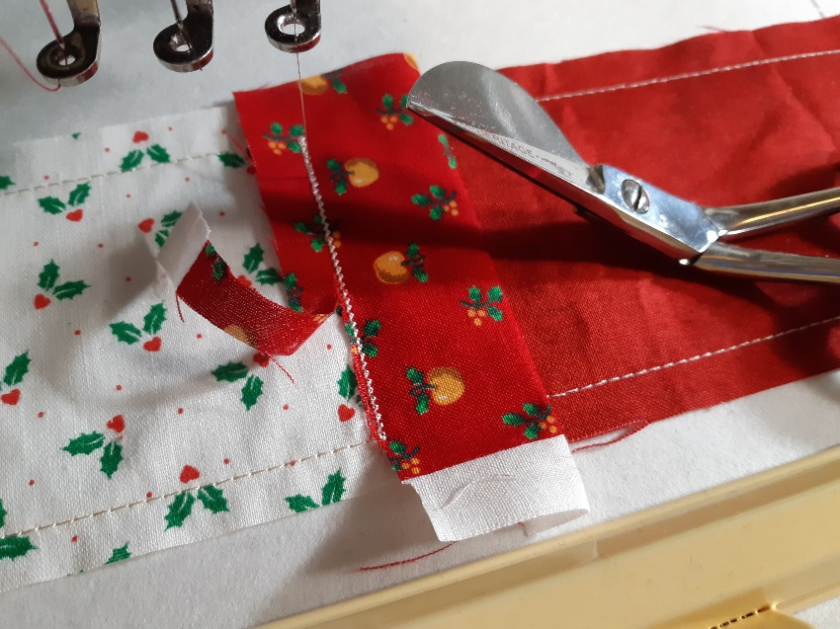

Repeat stage 3 for all four Short Borders.

- Run machine and stitch next color. It will be top decoration stitch.

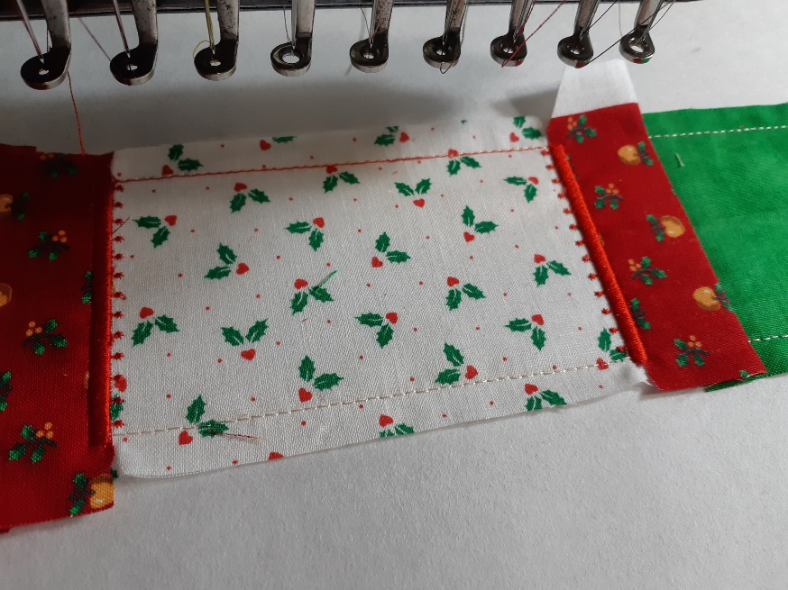

- Next stage - the machine will be tacking Center Piece of pillow.

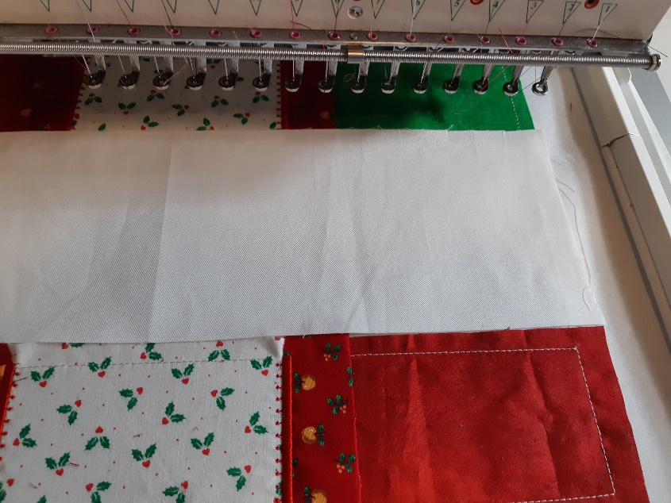

- Apply Long Border. Same technique as short border.
a - layout border upside down fabric
b – stitch seam to connect piece with border
c – bend border
d - Tacking border from second side. Stitch up to zigzag. It will indicate the aria their fabric will cut away. Remove hoop and cut extra fabric over seam.
Repeat it for both Long Borders.

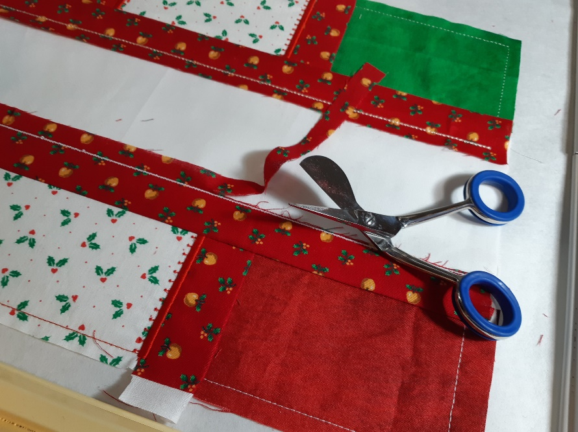

- Run machine and stitch next color. It will be top decoration stitch.
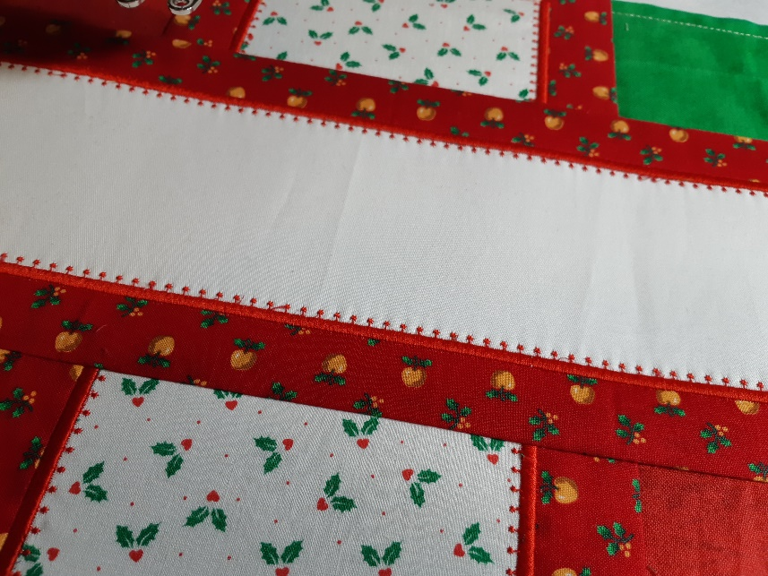

- Enlarge pillow from long site by extra pieces for pillow back fabric.

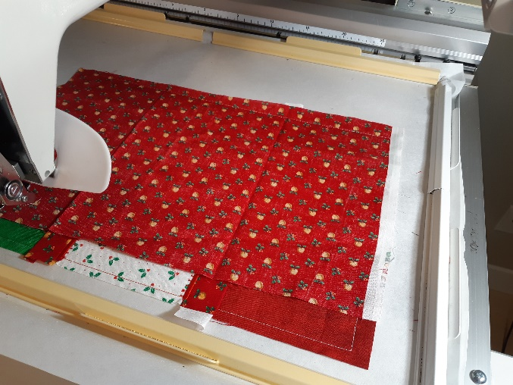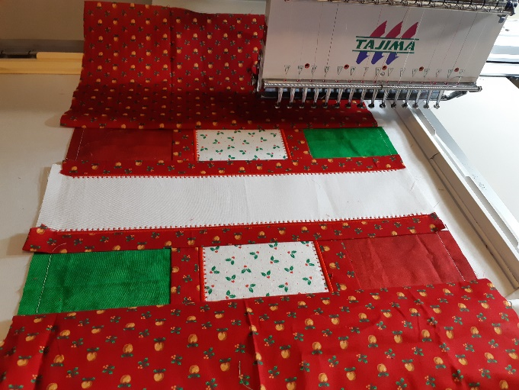

- Finish stitch design. Decorate pillow from front and back by additional designs.

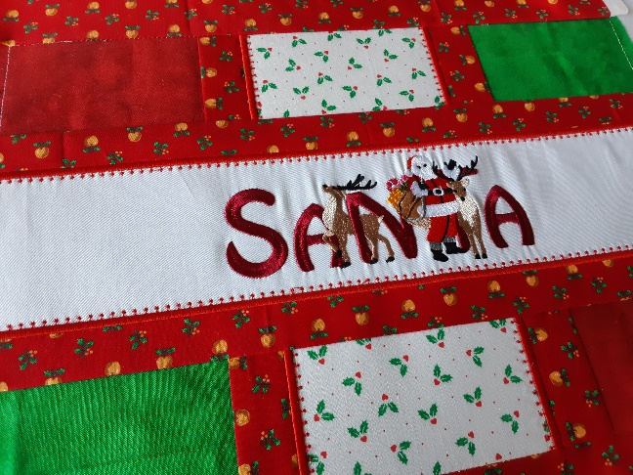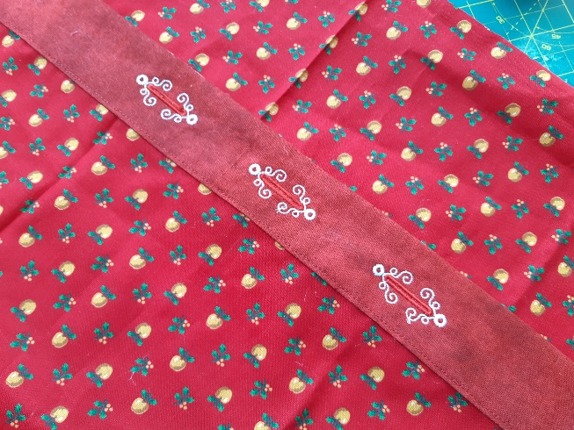

- Remove the design from the hoop and carefully tear off the stabilizer.

- Assemble pillow by sewing machine and your project will be ready!

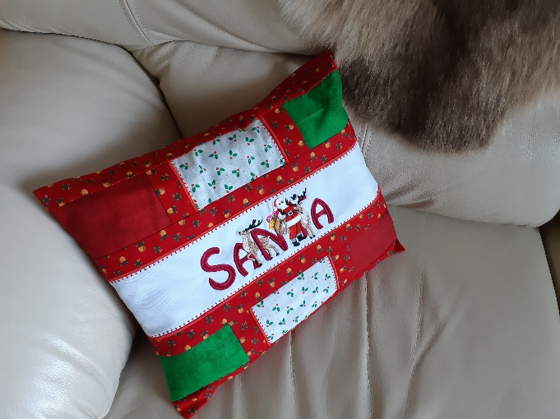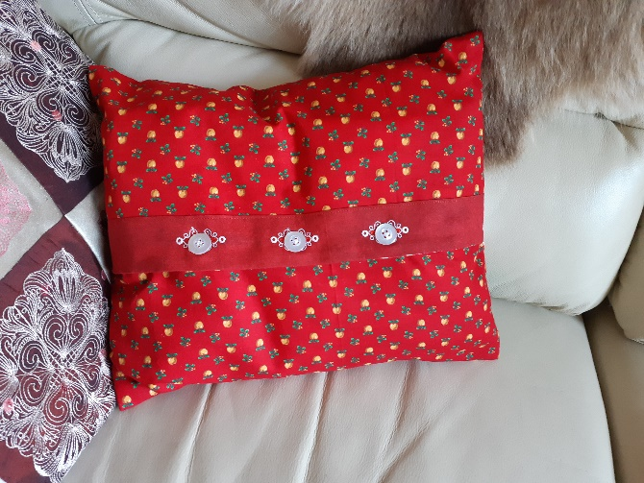

Enjoy your own pillow!

THANK YOU!

The Copyright for the digital design/pattern, text, pictures, instructions to create projects, and the embroidery files belongs to © www.ArtEmbroidery.ca, 2019. The design files are not allowed to be shared without permission.

There is no limit to the number of embroidery designs you can stitch out. You are allowed to stitch them out for personal or commercial needs (i.e. to stitch designs on items that are being sold). For items that are being sold, your item’s listing description must include "Embroidery Design by ArtEmbroidery" and link back to the ArtEmbroidery shop.

If you have any questions please fill free to contact me directly.
Liuba Tabunidze
Embroidery Digitizer

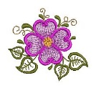 | ArtEmbroidery | www.ArtEmbroidery.ca
 | Email | LiubovEmb@gmail.com
 | FACEBOOK:  ArtEmbroidery Lovers Group | www.facebook.com/liuba.ArtEmbroidery  www.facebook.com/ArtEmbroidery.ca  www.facebook.com/groups/ArtEmbroideryLovers
 | INSTAGRAM: | www.instagram.com/liuba_art_embroidery
 | PINTEREST: | www.pinterest.com/znakv

